Metro Ticket Generating System
Project Design Phase
Solution Architecture, Data Model & UI Design

ServiceNow Platform | Version 1.0.0 | June 2026
Developed by Nithish Kanna

Introduction
This document describes the solution architecture, data model, and design decisions for the Metro Ticket Generating System built on the ServiceNow platform.

System Architecture
The system follows a layered architecture within ServiceNow. The presentation layer uses a Service Portal with Catalog Item widget. Client scripts provide input validation. A Before Business Rule handles fare calculation. Three custom tables store all data. Update sets enable source control and deployment.
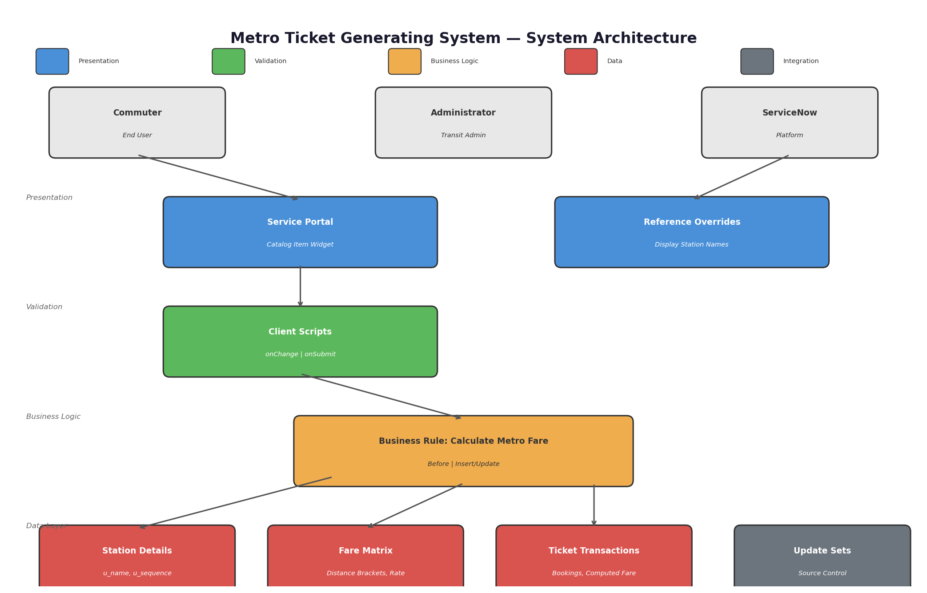
Figure 1: System Architecture Diagram

Entity Relationship Diagram
Three core tables form the data model. Station Details stores station names and sequence numbers. Fare Matrix defines distance brackets and rates. Ticket Transactions records each booking with references to start and end stations, quantity, and auto-calculated fare.
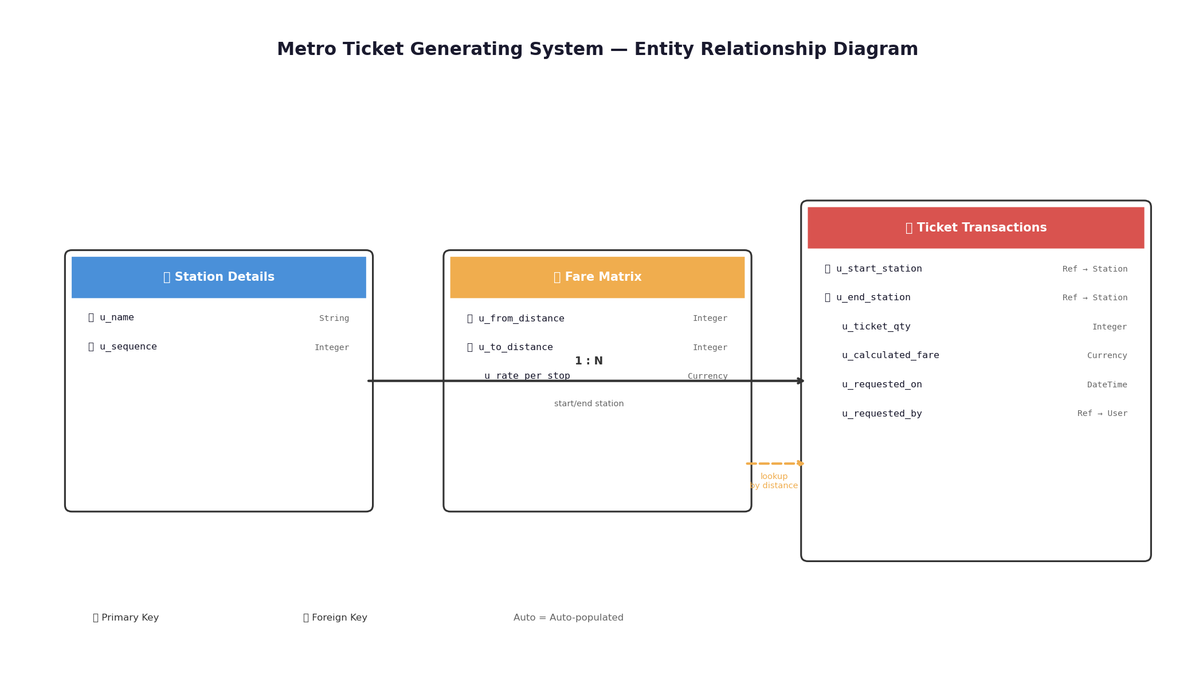
Figure 2: Entity Relationship Diagram

Fare Calculation Logic
The core business rule executes before insert or update on the Ticket Transactions table. It retrieves sequence numbers from the selected stations, calculates the absolute distance, queries the Fare Matrix for the matching distance bracket, and computes the total fare.
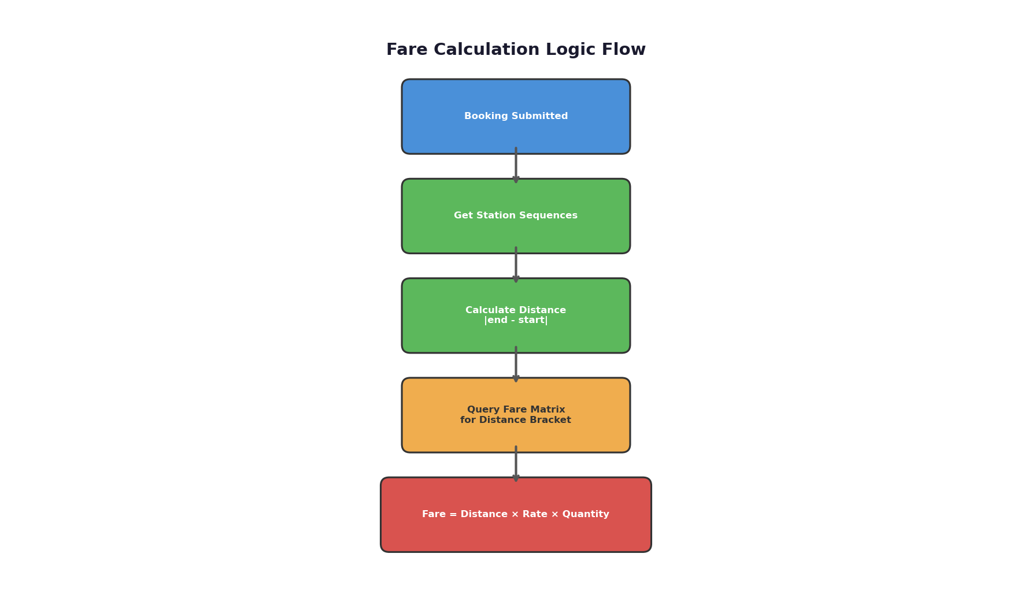
Figure 3: Fare Calculation Logic Flow
The calculation formula is:
Total Fare = |End Sequence - Start Sequence| × Rate Per Stop × Ticket Quantity

Client Scripts
Two client scripts enforce data quality:
onChange — Validate Stations:
When the user selects the ending station, the script compares it with the starting station. If both are the same, an alert is shown and the field is cleared.
onSubmit — Confirm Fare:
Before the form submits, the script verifies that the calculated fare is greater than zero. If not, submission is blocked with an error message.

Service Portal Design
The booking form is a Service Portal page using the Catalog Item widget pointed at the Metro Ticket Purchase item. The form includes:
- From Station — Reference dropdown showing station names in sequence order.
- To Station — Reference dropdown with the same station list.
- Ticket Quantity — Integer field (1-10).
- Calculated Fare — Read-only currency field auto-populated by the Business Rule.
- Submit Button — Triggers validation and creates the transaction.
The layout is responsive and works on both desktop and mobile devices. Reference fields display station names instead of sys_id values through dictionary overrides.

